**Laserfiche Apps Deployment Steps**

Once we get the “.sppkg” file from the source, we need to go to SharePoint page followed by the site collection where you want to deploy the solution and use the Apps.

Go to site’s **App catalog** by clicking **Site contents** on the left navigation as shown below.

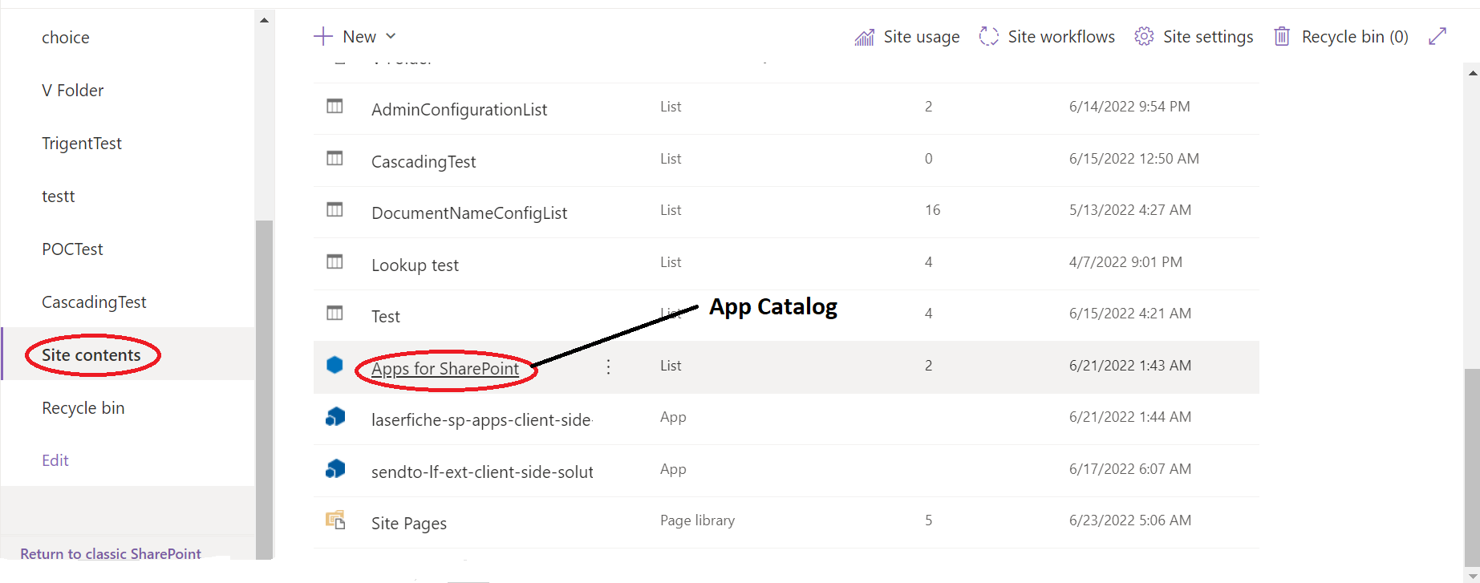

Once you click on **App for SharePoint** and enter, it would look like the following image. Either you can click on Upload button or drag and drop the .sppkg file here.

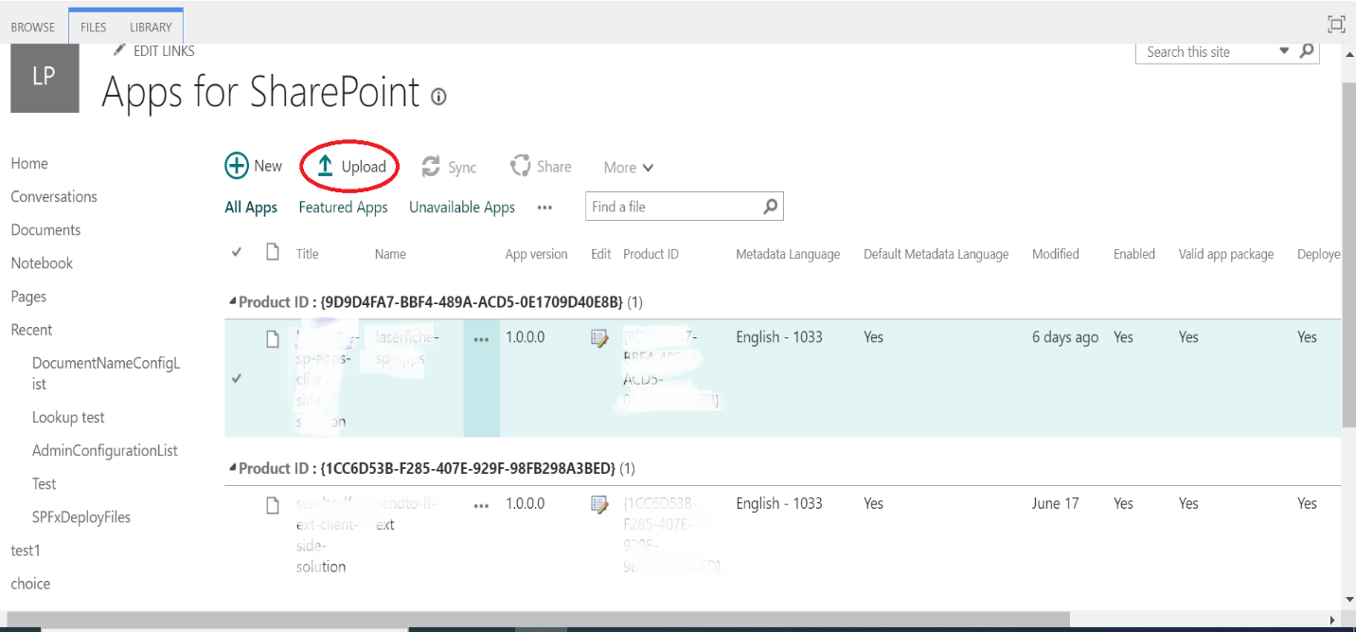

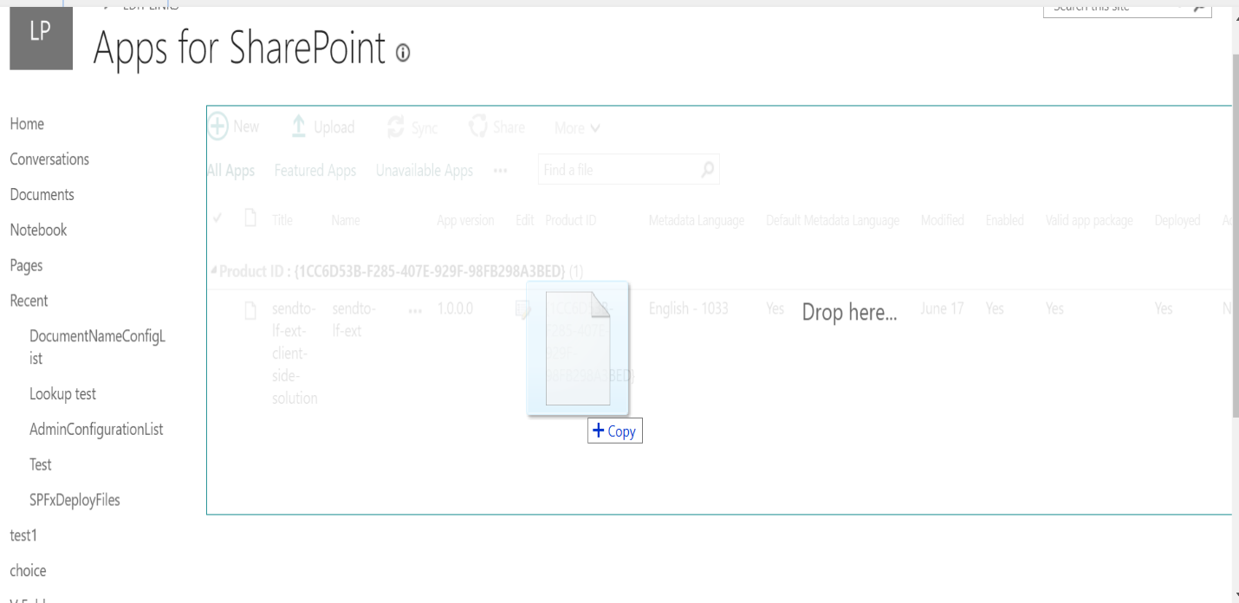

Soon after uploading the file, you will see a confirmation dialog box (as shown below) for deployment. Where you must click on **Deploy**.

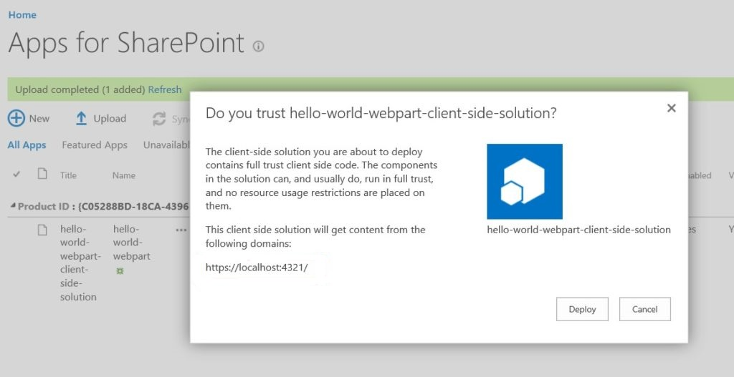

After deployment we need to go back to **Site contents** and click on **add an app.**

Below shown Site contents images in both classic and modern view.

**Classic SharePoint**

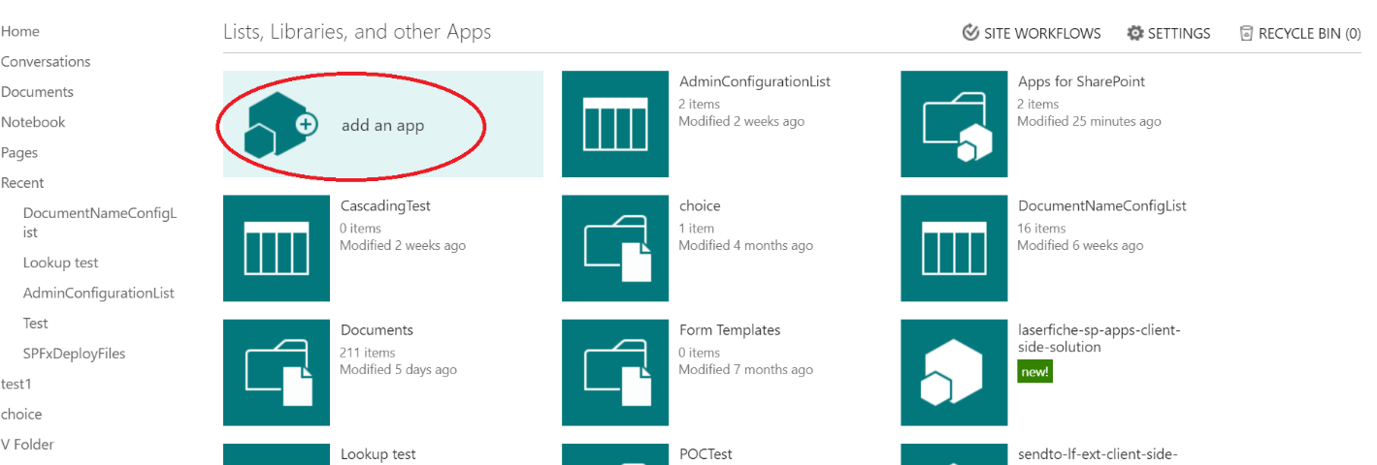

**Modern SharePoint**

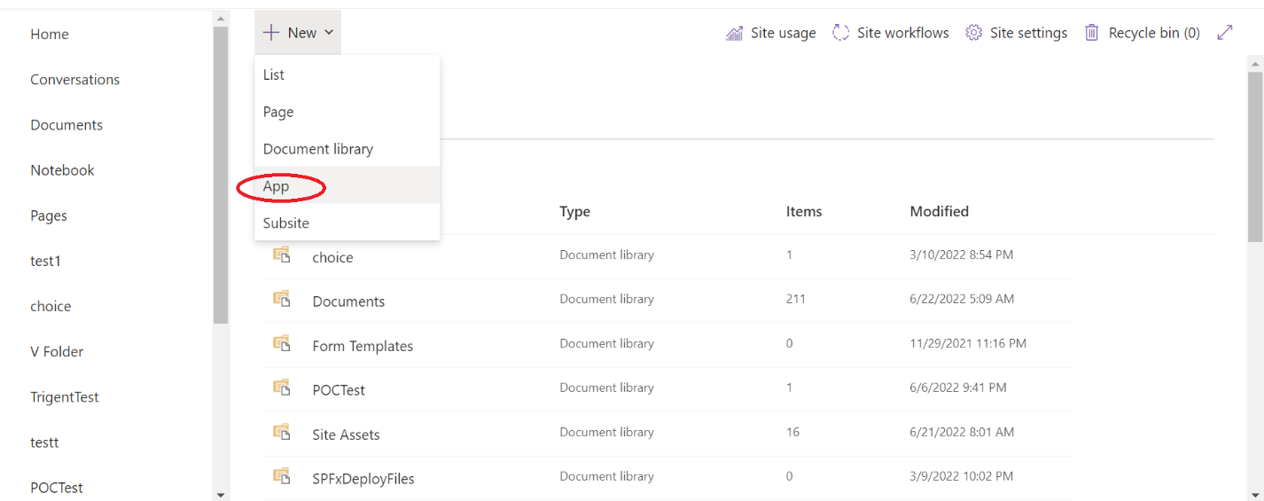

After this you need to select the appropriate app that you deployed and add to use its functions. You can add apps from **Apps you can add** section as shown below.

**Classic view**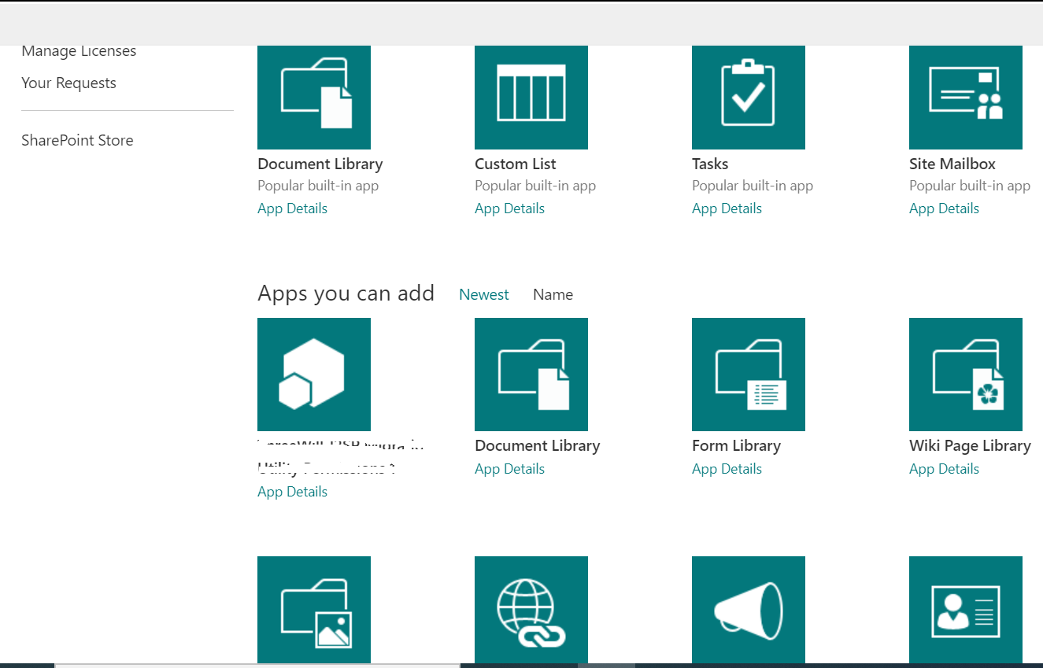

**Modern view**

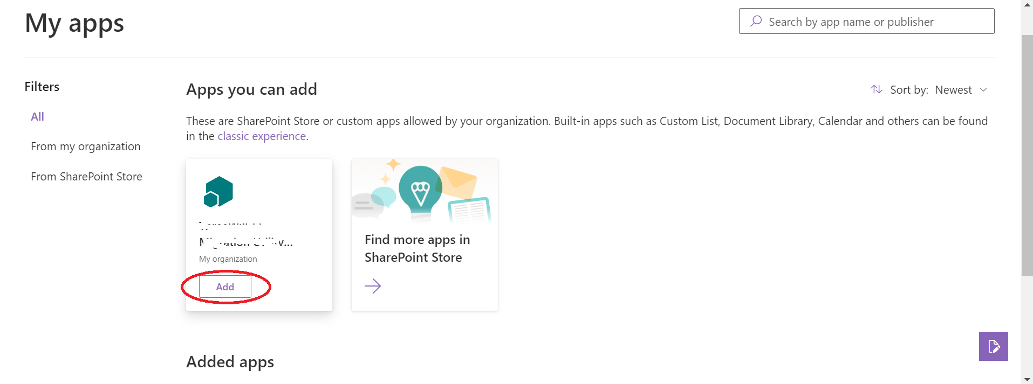

Once after successful completion of the deployment and adding App, the app is now available to use. In order to use the app, you can go to any page in **Pages** sectionfrom left navigation.

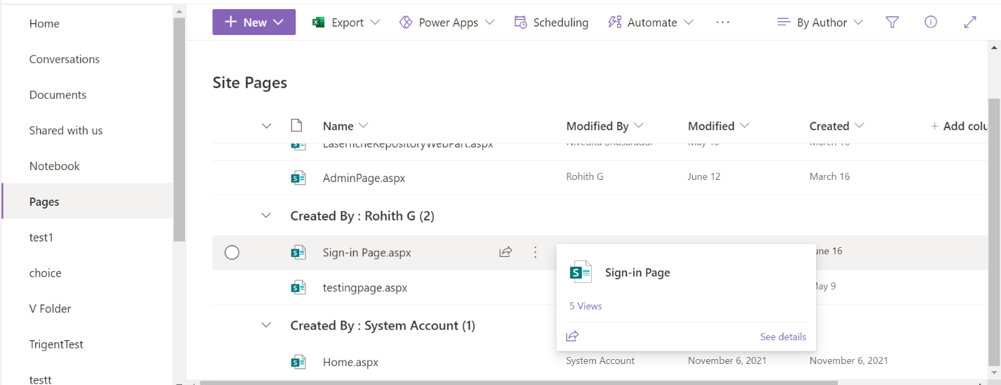

Edit the selected page and add desired webparts in it and publish it.

If there are no pages available then you can create pages from the **Site contents** as follows.

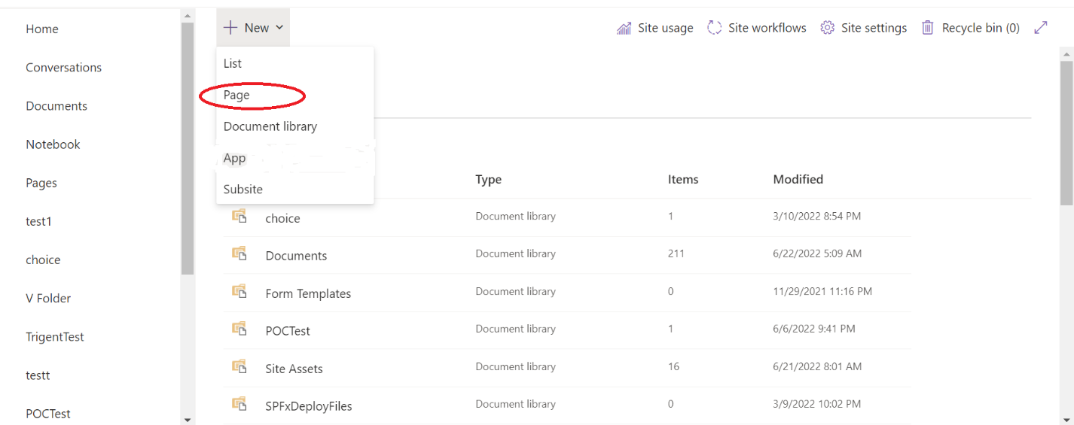

After clicking on page, you need to provide page names as follows for respective webparts.

**Repository Access: -** you have to provide name as “LaserficheRepositoryWebPart” followed by select the webpart, Add properties like “**Region”,”Dev Mode”**  and publish as shown below.

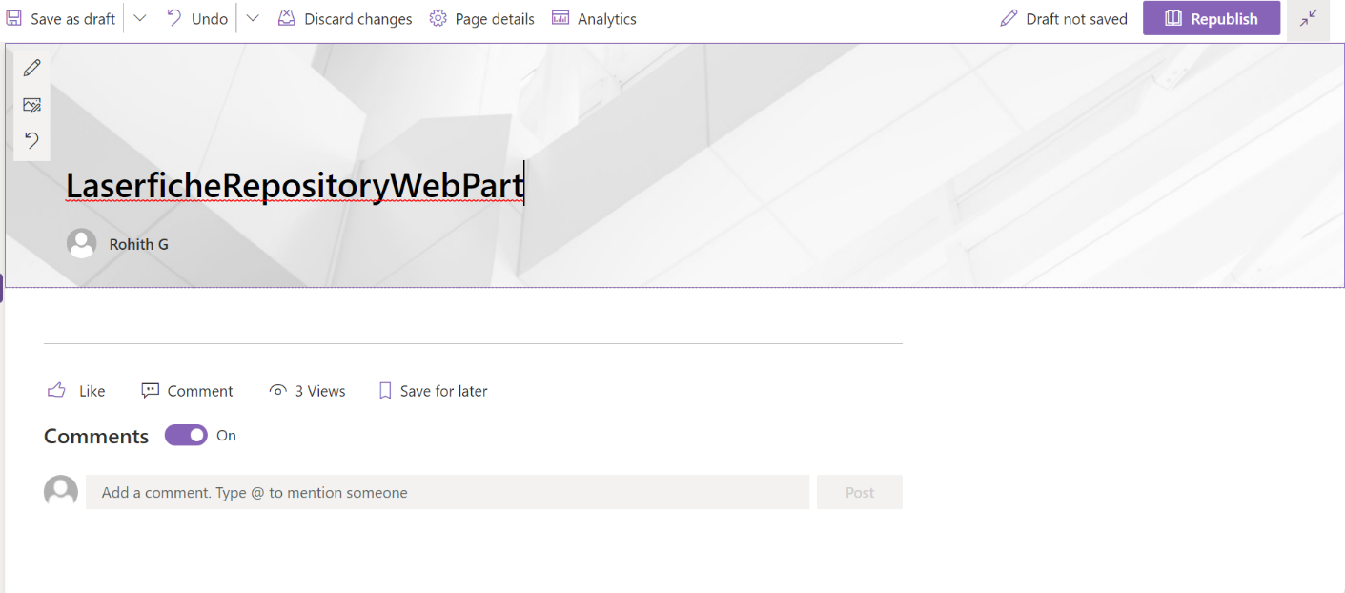

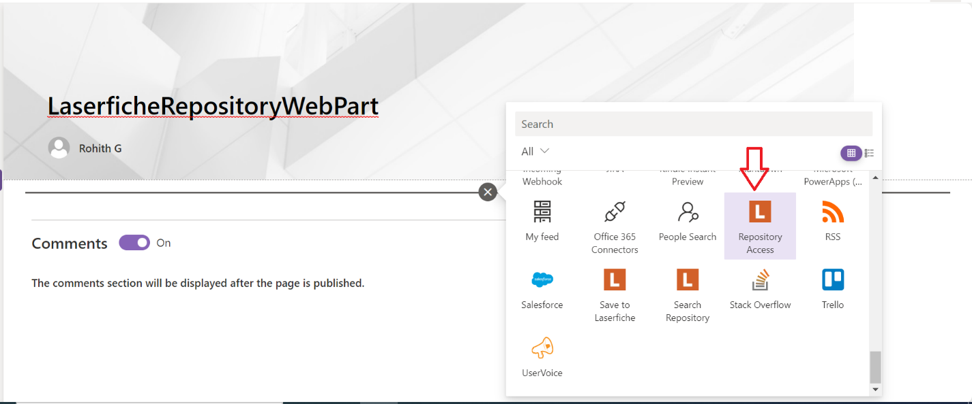

(P.T.O)

Please click on the edit the webpart

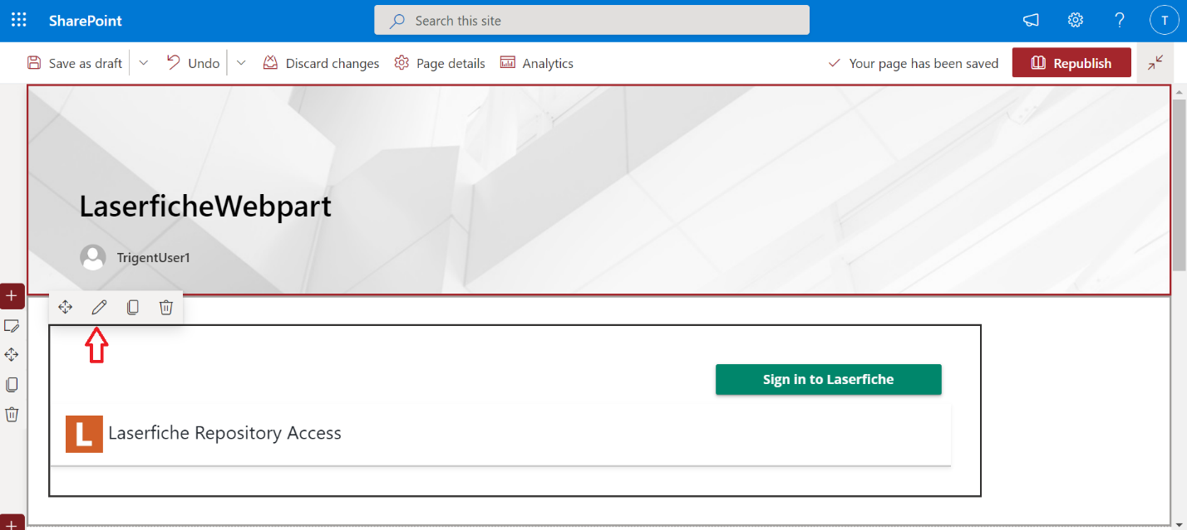

Then you’ll see web part properties on right side panel, in which you need set the Region as **US**(America) or **CA**(Canada) or **EU**(Europe), according to your Location.

**Note: -** You Do not turn on **Dev Mode** shown in the below pic unless you want to use Development sites. In case you have selected Dev mode again you need to change the Region According to your Location

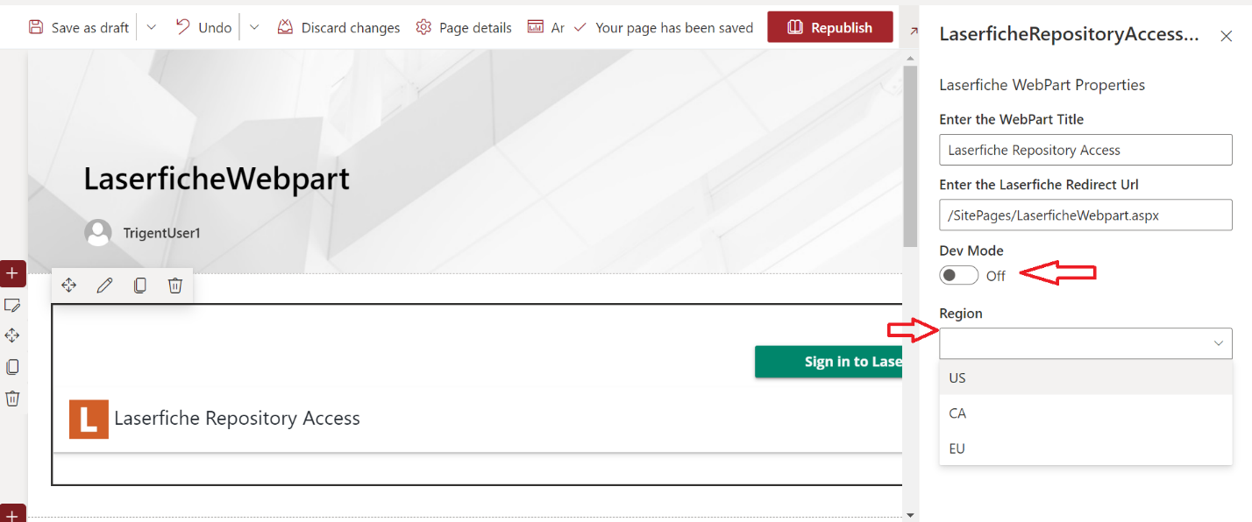

**Admin Configuration: -** you need to provide name as “AdminPage” , followed by select webpart and publish

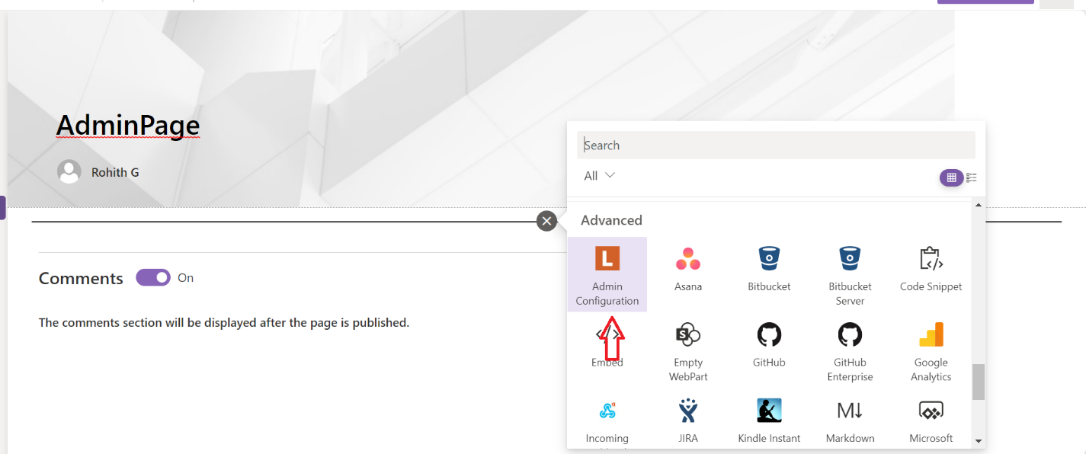

(P.T.O)

Please click on the edit the webpart

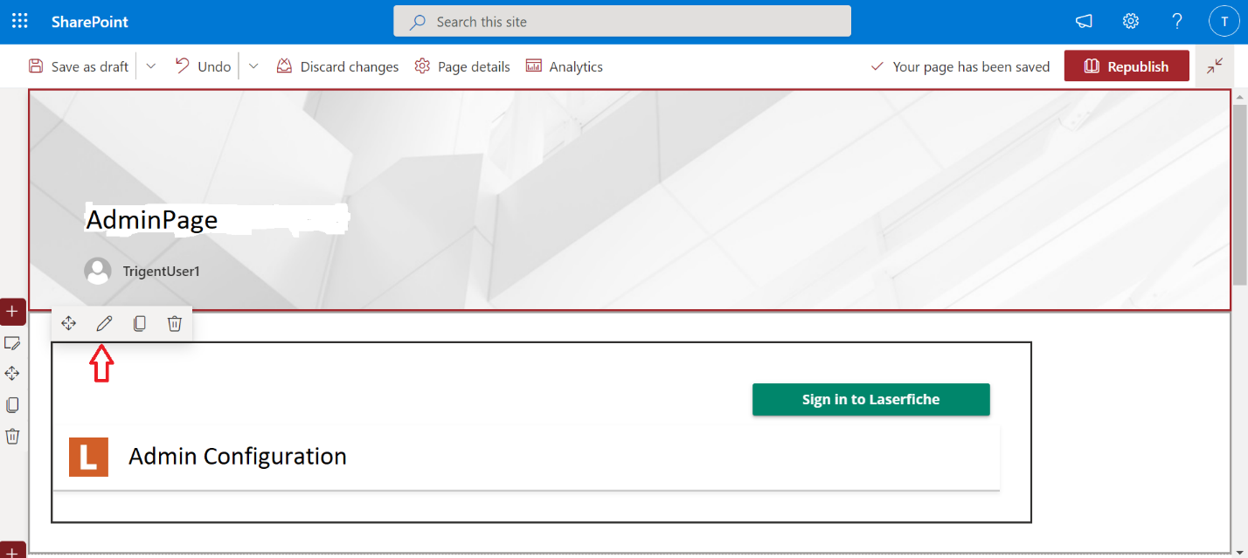

Then you’ll see web part properties on right side panel, in which you need set the Region as **US**(America) or **CA**(Canada) or **EU**(Europe), according to your Location.

**Note: -** You Do not turn on **Dev Mode** shown in the below pic unless you want to use Development sites. In case you have selected Dev mode again you need to change the Region According to your Location

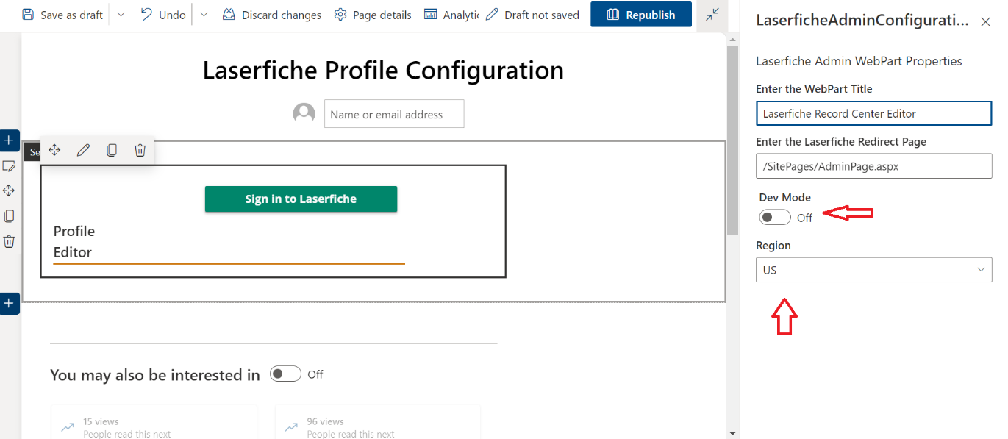

**Save to Laserfiche: -** you need to provide name as “Sign-in Page”, followed by add the webpart as shown below.

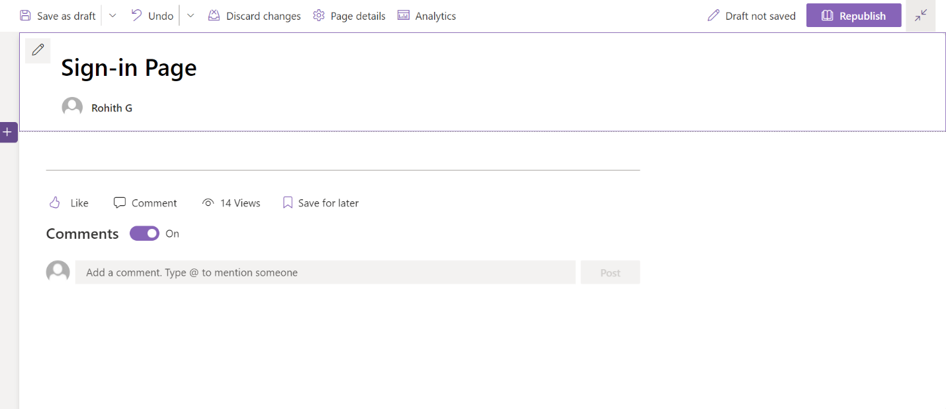

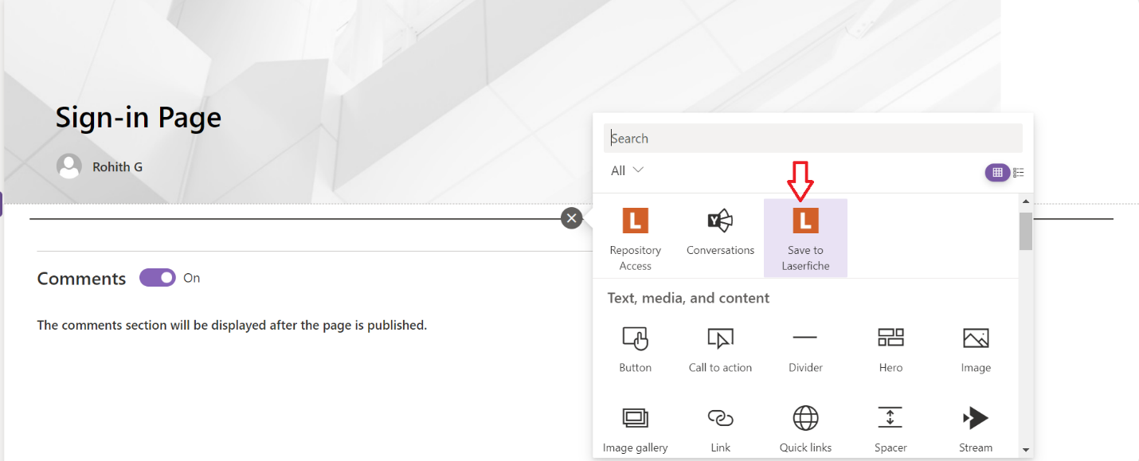

(P.T.O)

Please click on the edit the webpart

Then you’ll see web part properties on right side panel, in which you need set the Region as **US**(America) or **CA**(Canada) or **EU**(Europe), according to your Location.

**Note: -** You Do not turn on **Dev Mode** shown in the below pic unless you want to use Development sites. In case you have selected Dev mode again you need to change the Region According to your Location

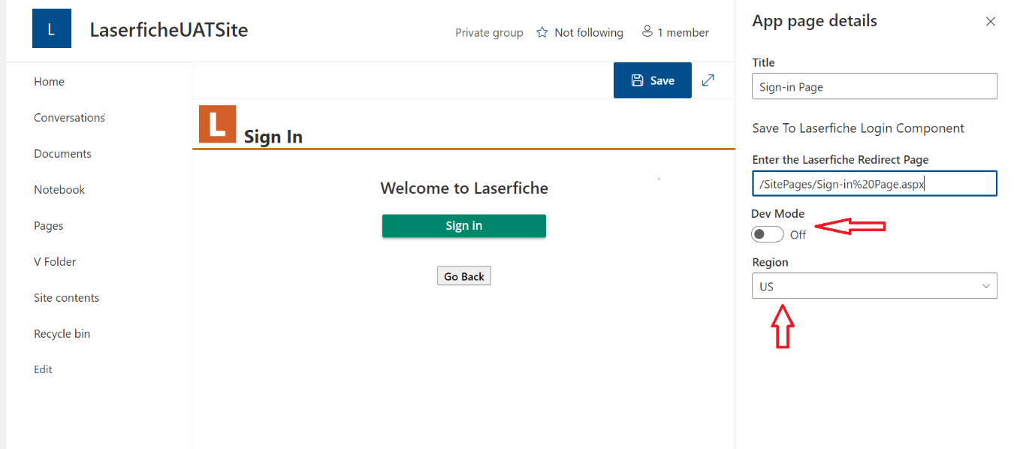

**Note: -** for Sign-in Page once after you create the page, you need to manually go to pages and rename it as shown below in order to work properly.

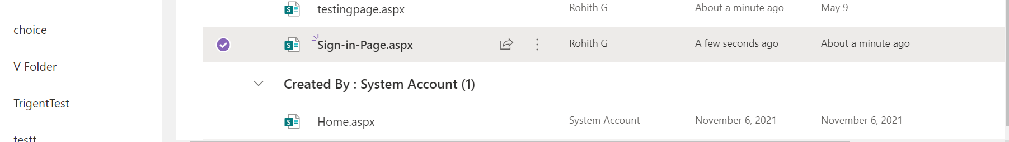

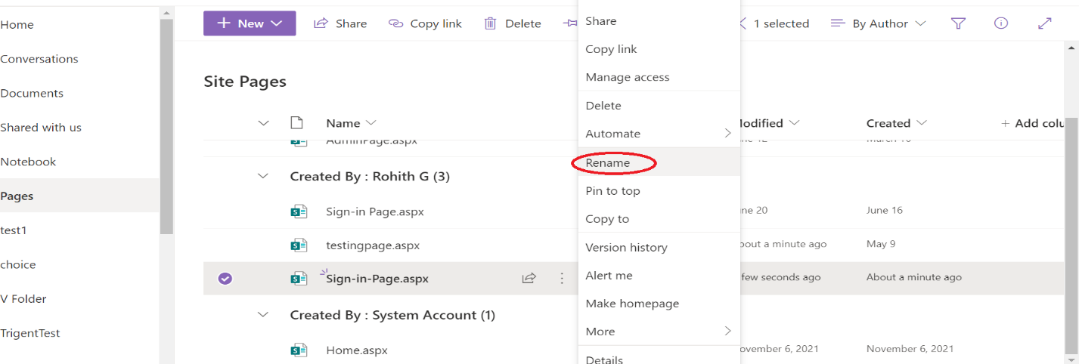

You need to provide space before Page instead of “-” symbol as shown below and click on Rename.

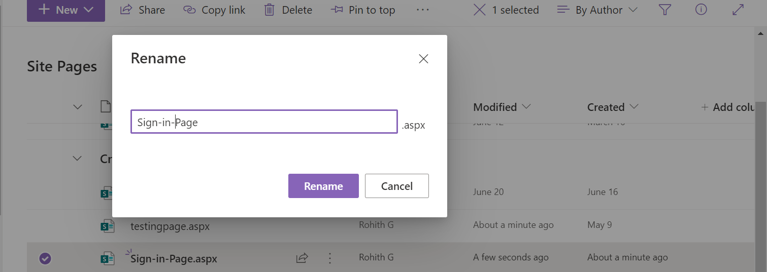

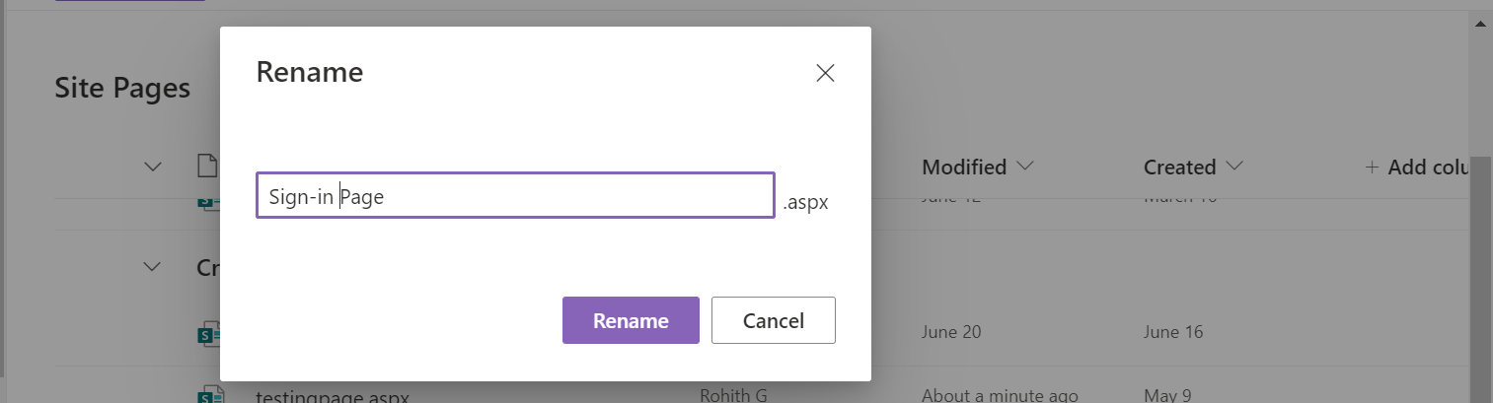

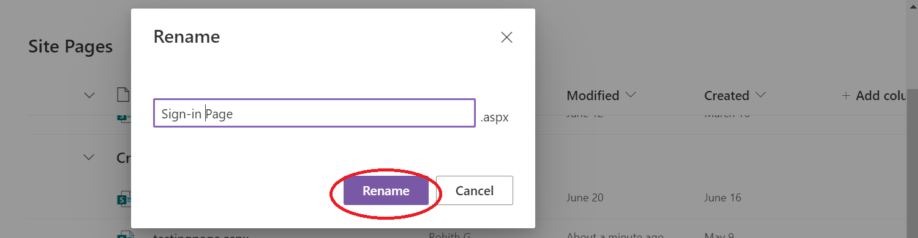

After all these above steps and in order to use the pages that are created and published with Laserfiche webparts, you need create an app in **Laserfiche Developer Console** and add redirect URI’s to make the pages authenticatable.

Follow the below steps to finish the Setup: -

Please click on here for [US](https://app.laserfiche.com/devconsole) (America) or [CA](https://app.laserfiche.ca/devconsole) (Canada) or [EU](https://app.eu.laserfiche.com/devconsole) (Europe) to go to Laserfiche Developer Console page(as shown below).

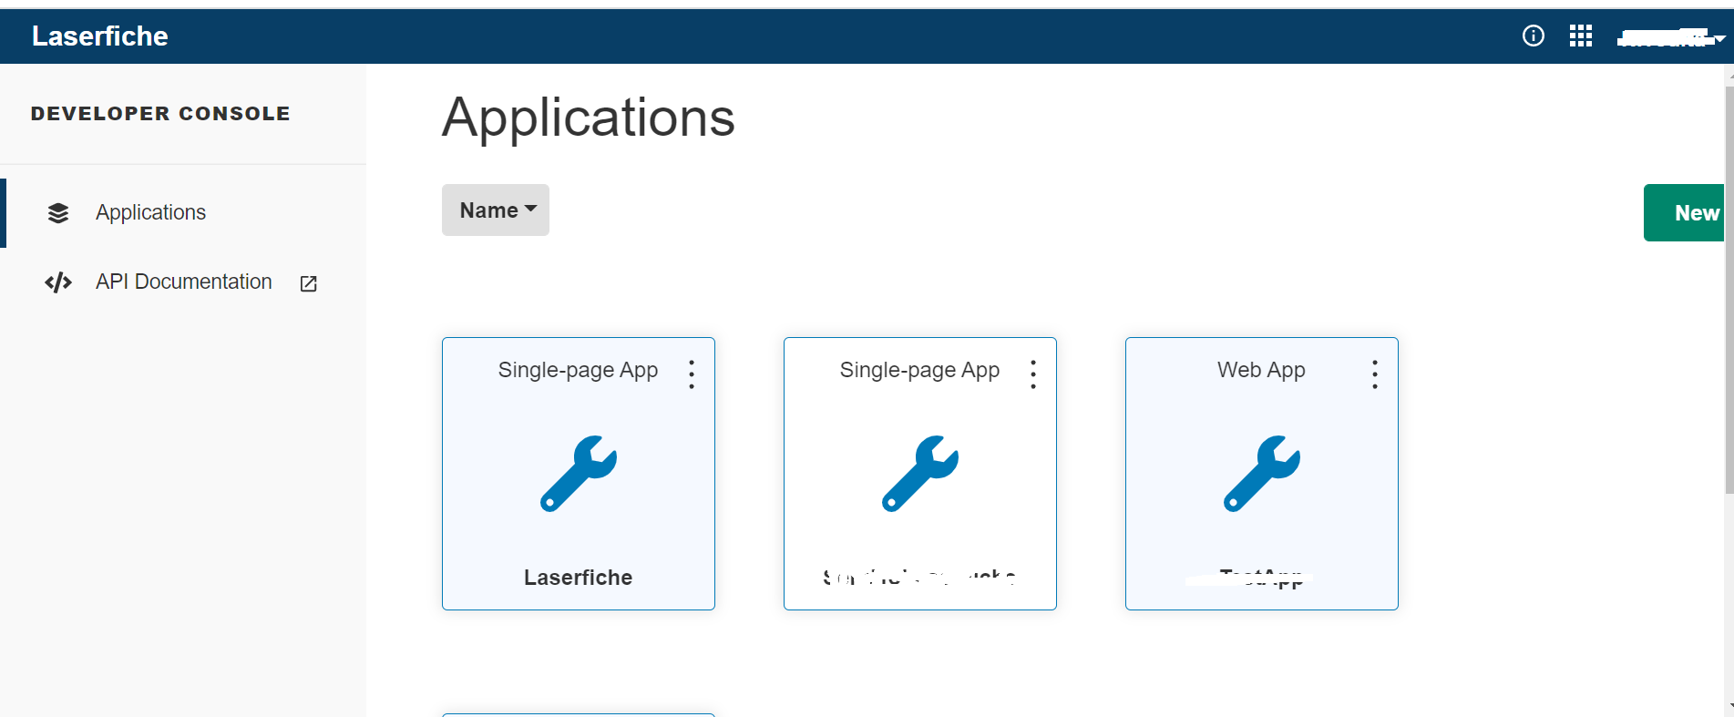

If you are not already logged in, then please login with your respective Laserfiche credentials. After successful login you can be able to see above image.

Now you have click on new button as shown below.

(P.T.O)

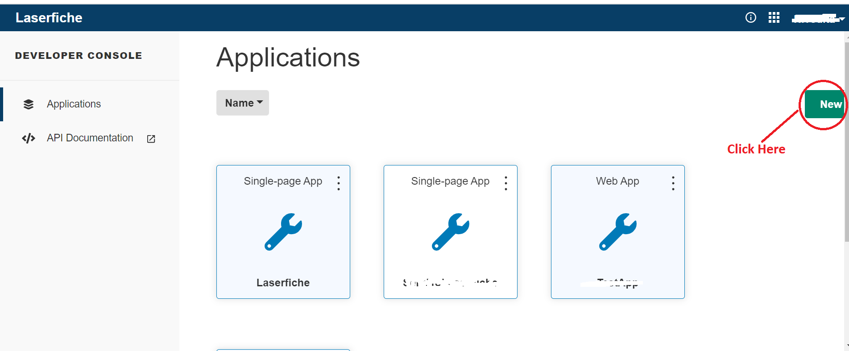

Now you will see a dialog box as below and click on the option as instructed in the below image.

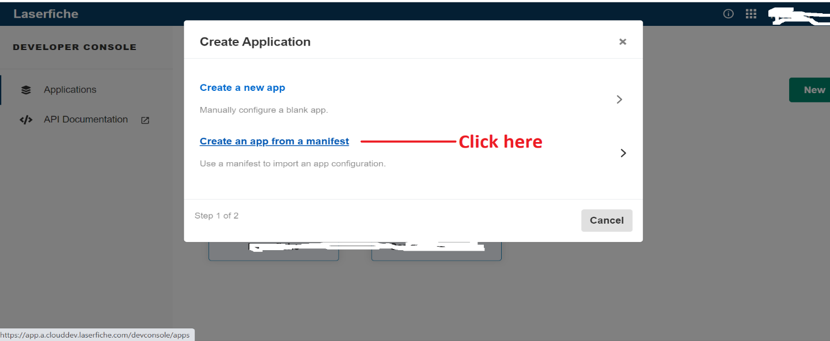

In order to upload, follow the below steps to make a “.json” file.

Please double click on this document , then it will open a notepad with some JSON text inside as shown below.

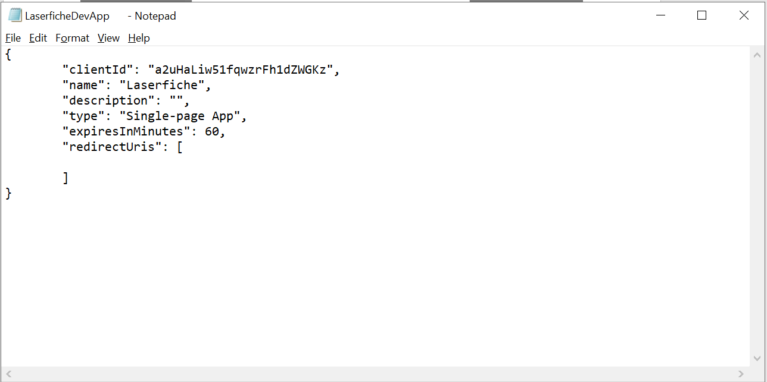

Please click on **save as** or (ctrl+Shft+S) and then at **File name** section add “.json” extension before saving as shown below. So, that it will be a JSON file and can be able to create an app in Developer console.

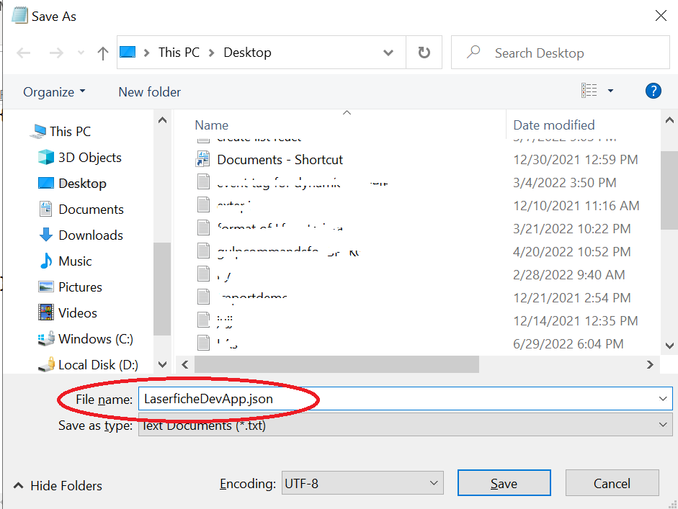

Save the file anywhere you want and remember the path of this file, so that it won’t be difficult while uploading.

After that click on **choose file** and upload the document as given instructions below.

It will look like below images.

**Before uploading**

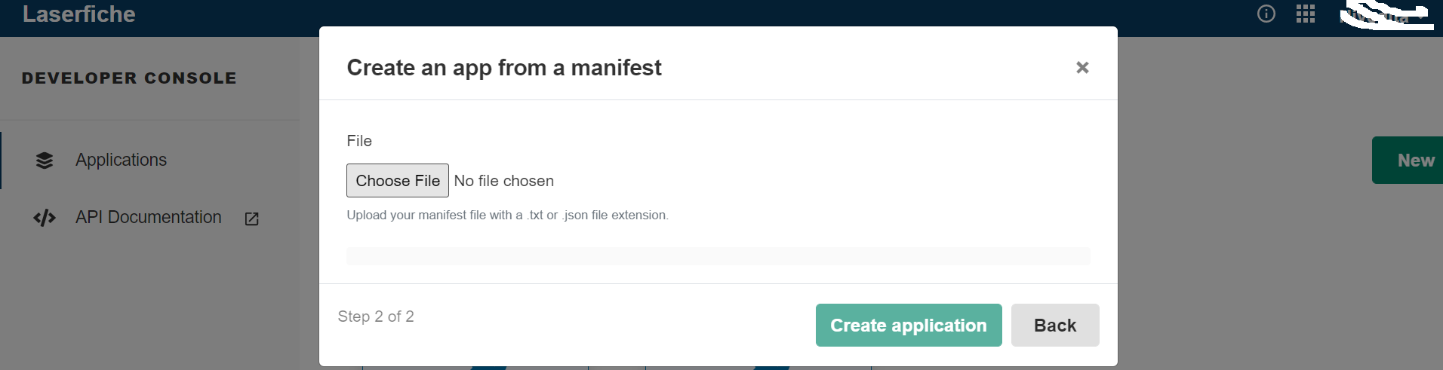

**After Uploading: -**

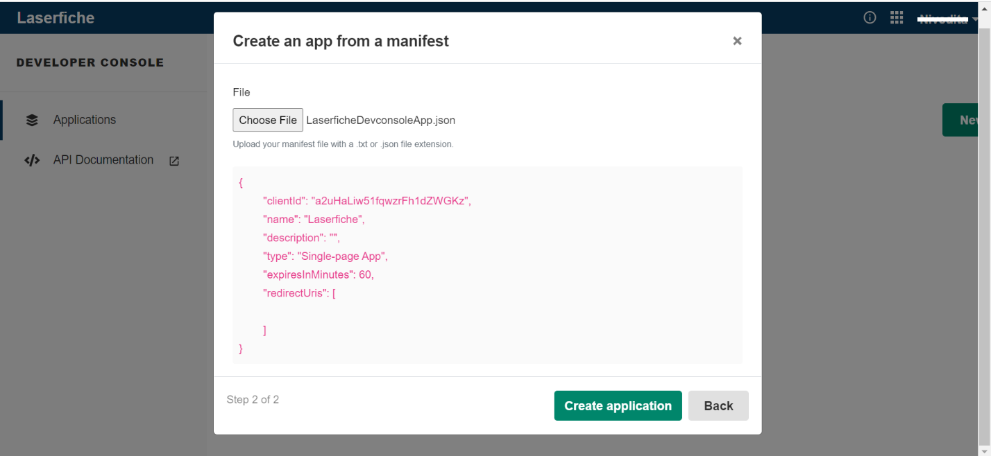

Once after uploading click on **Create application**.

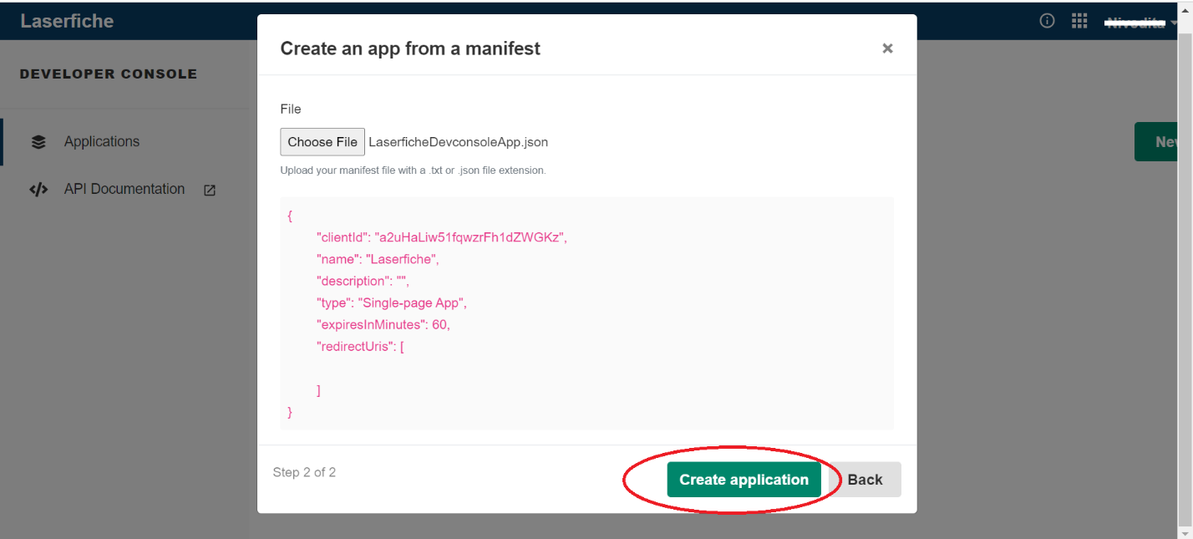

Now you can be able to see an App named Laserfiche created, and you should be seeing the below shown image saying warning message as “Single-page apps require at least one redirect URI to be usable.”

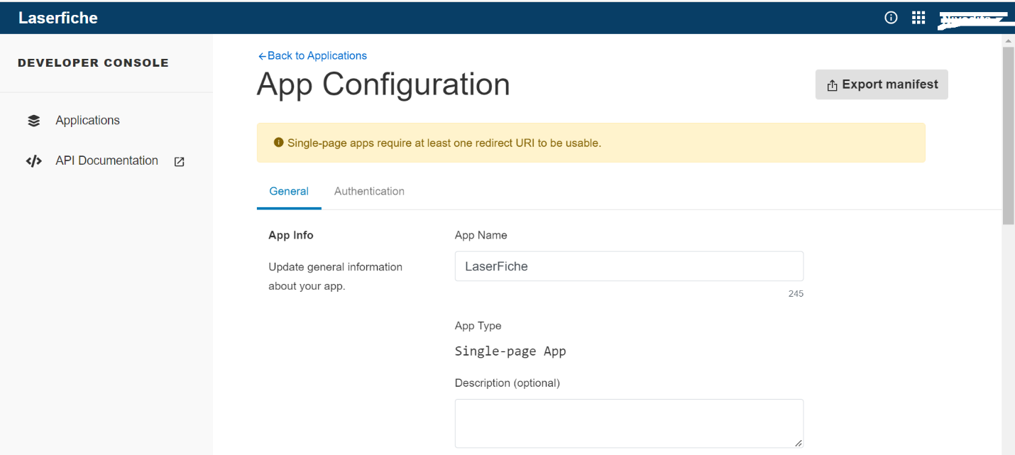

Now you have to click on **Authentication**.

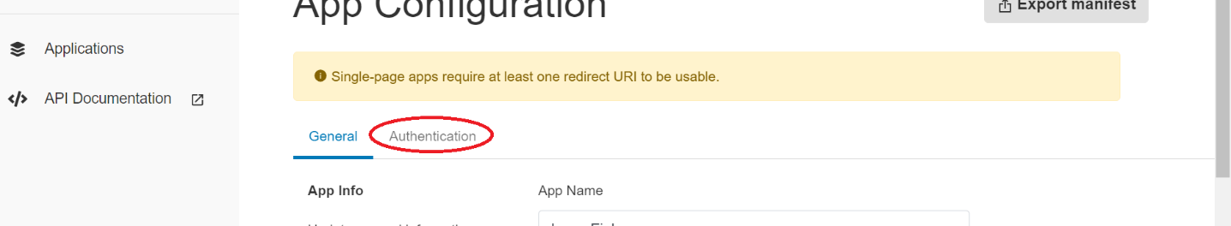

Then you can see **Redirect URIs** section as shown below where we have to add the URLs of the pages, we have created little earlier by following this documentation.

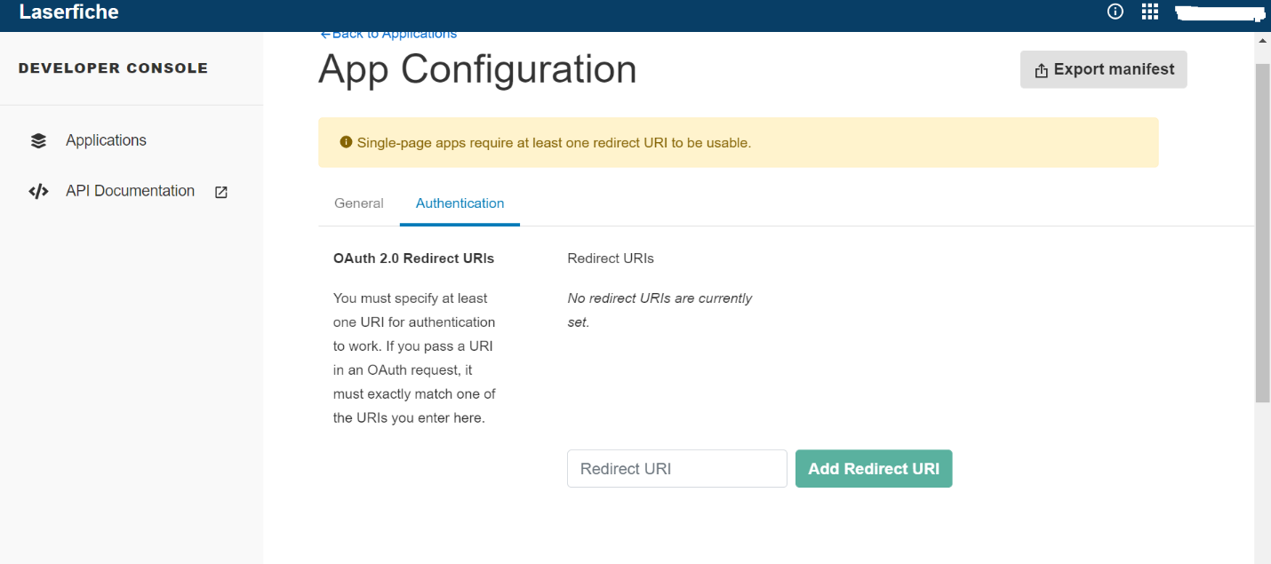

Now you can go to your Site collection where we have added the Laserfiche apps and created pages and published with Laserfiche apps in it.

If you click on Pages, then you can see site pages section on right.

Please click on all the three pages as shown below and copy their URLs from the browser and paste it to a note pad or anywhere you are comfortable with

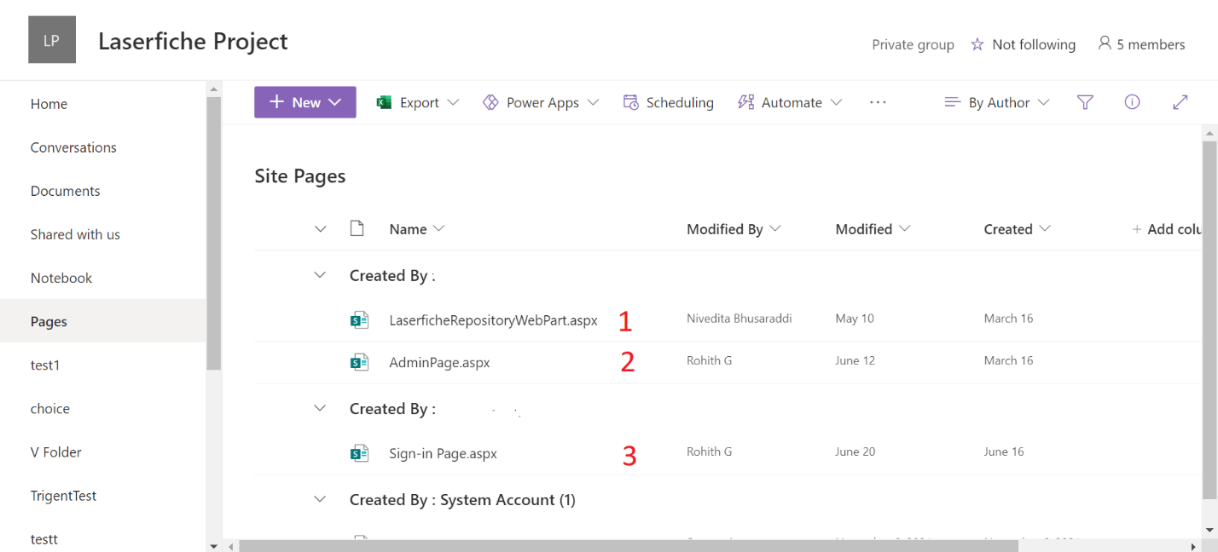

It should be shown as below

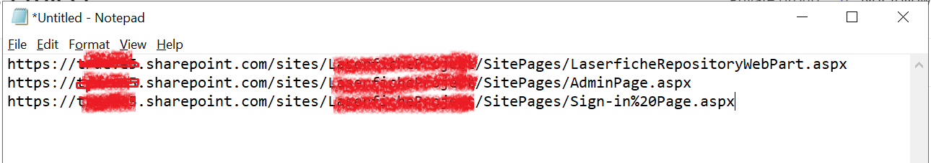

Now go back to Developer Console app page where we have to add Redirect URIs

And paste all the three links one by one there and click on **Add Redirect URI** as shown in below image

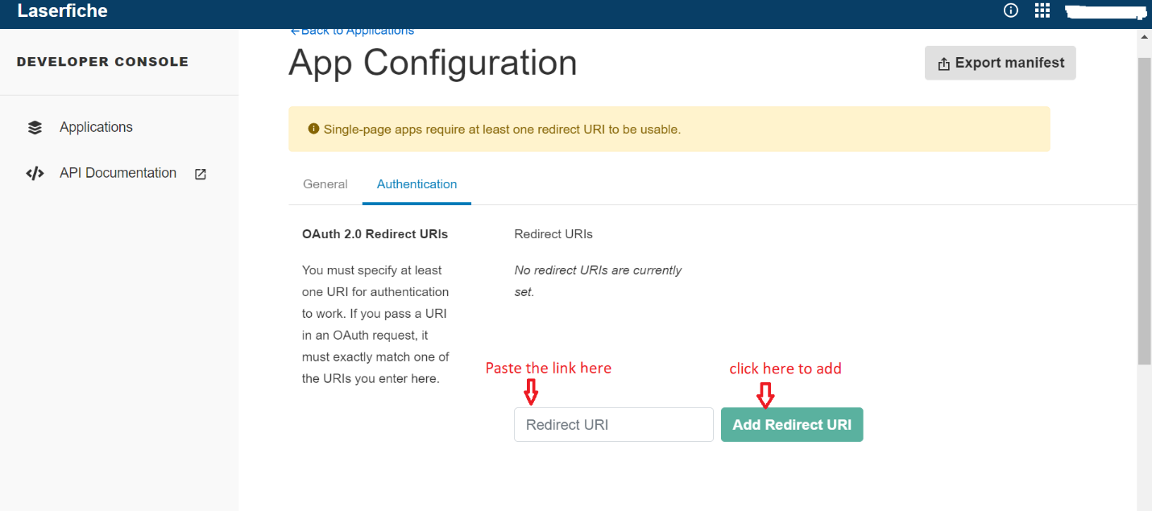

Once after we add all these redirect URIs in Dev console app then we are good to use the three Laserfiche apps which we have published in pages in Site collection.

Now you can go to pages click on any respective page where Laserfiche apps are published, there you can see login button (if not logged in already) click and authorize using your Laserfiche credentials and enjoy the Laserfiche services.